RIHAM AHAMED ABDUL RAHEEM

HND COMPUTING IDM

PROBLAM SOLVING

Contents

**PROBLEM SOLVING** 1

Problem solving skills 1

Problem solving process 1

Tools and methods 11

Brainstorming 11

SWOT analysis 13

Whys method 15

Drill down method 16

**List of figure**

Figure 1: Problem-solving process cycle 1

Figure 2: Evaluation 10

Figure 3: Brainstorm 11

Figure 4: SWOT 13

Figure 5: Whys analysis of our problem 16

Figure 6: Drilldown method for our training program 17

**List of table**

Table 1:Problam analysis 2

Table 2: Analyzing the solutions 5

Table 3: Select the best solution 9

Table 4: Strength 13

Table 5: Weakness 14

Table 6: Oppertunities 14

Table 7: Threats 15

# **PROBLEM SOLVING**

## Problem solving skills

The process of working through details of a problem to reach a solution. Problem solving may include mathematical or systematic operations and can be a gauge of an individual's critical thinking skills. (businessdictionary.com, © 2018 WebFinance Inc.)

## Problem solving process

Figure : Problem-solving process cycle

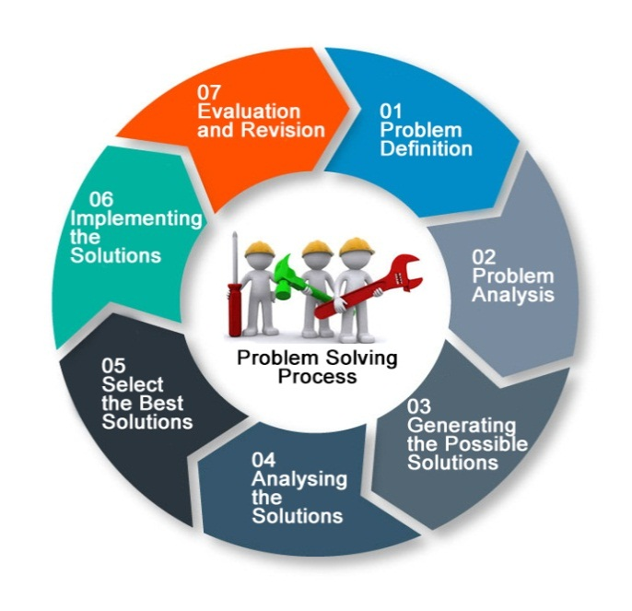

1. **Problem definition –** List down our problems, which we faced in the training event.

* Lack of contribution of group members.
* Issues in assigning designations.
* Group members’ poor concentration and laziness in tasks.
* Poor attendance of group members.
* Difficulties in arranging equipment for the training programme.
* Financial problems.
* Time management problems.
* Delays in getting permission in target school.
* Issues within the team.

1. **Problem analysis –** Analysis the effect and nature of the problem

Table :Problam analysis

|  |  |
| --- | --- |
| **Cause** | **Effect** |
| Lack of contribution of group members. | * The outcome of the training event will become worse. * The tasks will not complete before the deadline. |
| Issues in assigning designations. | * It creates an environment, where conflict raise between the group members’ opinions. |
| Group members’ poor concentration and laziness in tasks. | * It will be led to waste time. |
| Poor attendance of group members. | * The workloads will be increase. |
| Difficulties in arranging equipment for the training programme | * It will make the training programme more complicated. |
| Financial problems. | * It affects the quality of the training programme. |
| Time management problems. | * We may not be able to finish the job within time. * The quality of the training programme will be worse |
| Problems in getting permission in target school. | * It will be led to waste time and money. * Stress will be increase |
| Issues within the team | * Time will be spending on unnecessary matters. * The unity between the members will be affected. |
| Unsatisfied knowledge in presentation skills | * The presentation will be unprofessional and poor quality. * It will lead to spending more time on rehearsals. |
| Some overlapping tasks | * The concentration of group members will be reduced. |
| Improper interpersonal skills | * It may lead to disagreements between stakeholders. * Members will not be able to manage the stress and time. * Members will not be able to make decisions during complicated situations. * It may cause communication problems between the stakeholders. |

1. **Generating the possible solutions –** Write down every possible solution for a problem
2. Lack of contribution of group members –

* Encouraging group members to contribute.
* Communicate every person in the group and discuss their problems and sort out it.
* Giving tasks and works to each person in the group.

1. Issues in assigning designations.

* Discuss with all.
* Assign designation as per their experience.
* Organize a voting method to assign designations.

1. Group members’ poor concentration and laziness in tasks.

* Deal with their distraction.
* Giving penalty to the not concentrating member with the tasks.
* Work for short time and take rest and refresh.

1. Poor attendance of group members.

* Prepare a professional schedule that fits for everyone in the group.
* Connect with everyone via messaging apps and chatting.
* Track absence and punish them.

1. Difficulties in arranging equipment for the training programme

* Communicate with our institute stakeholders and requesting them.
* Requesting from the school management.
* Buy new equipment.

1. Money arranging problems.

* Asking from group members and our institute.
* Making budget plans.
* Gathering sponsors.

1. Time management problems.

* Making a professional schedule.
* Gathering help from out of the group and friends.
* Leave the task, which does not get finished and start the new task.

1. Problems in getting permission in target school.

* Communicate with the school management and explain our objectives effectively.
* Change the targeted school.
* Postpone the training event.

1. Issues within the team

* Develop good communication skills.
* Discuss with all and sort out the problems.
* Get guidance from our lectures.

1. Unsatisfied knowledge in presentation skills

* Do rehearsals repeatedly.
* Get knowledge from experienced persons.

1. Some overlapping tasks

* Following some time management skills.
* Giving priority to most important tasks.

1. Improper interpersonal skills.

* Learn from lectures.
* Learn from internet or some external sources.
* Get guidance from experienced persons.

1. **Analysing the solutions –** Analysis the pros and cons of each solution

Table : Analyzing the solutions

|  |  |  |
| --- | --- | --- |
| **Solution** | **Advantage** | **Disadvantage** |
| Encouraging group members to contribute. | Group members could be encouraged and show interest in the training event. | Some group members cannot be understood. |
| Communicate every person in the group and discuss their problems and sort out it. | Group members’ problem will be sorted and they show interest in training event | When try to communicate with every single person the time will not be saved. |
| Giving tasks and works to each person in the group | Group members should be engaged in tasks. | If they still not contribute to the tasks all the plans will collide. |
| Discuss with all. | Maybe sort out the issues | This will lead to waste time |
| Assign designation as per their experience. | Experienced persons could be leading the team. | Non-experienced person will be avoided from getting experience as a leader |
| Organize a voting method to assign designations | The leader will be elected by the will of the majority group members. | Sometime selected person will mislead the group |
| Deal with their distraction. | Maybe it is very effective in reconstruct the members’ concentration. | This will lead to waste time |
| Giving penalty to the not concentrating member with the tasks. | Members will be forced to concentrate in the tasks. | Members will hate the strictness and leadership |
| Work for short time and take rest and refresh | it is very effective in reconstruct the members’ concentration and decrease the laziness. | Sometimes it can lead to delays in works. |
| Prepare a professional schedule that fits for everyone in the group. | It will help to increase the members’ attendance without making critical problems. | Maybe face some conflicts when considering as fits for everyone. |
| Connect with everyone via messaging apps and chatting | It will help to communicate with the persons, who were not coming to the discussions. | Sometimes they will misunderstand what we tried to explain. |
| Track absence and punish them | This will helps to track members’ absence and increase their presence | Members will hate the leadership when we try to punish them. |
| Communicate with our institute stakeholders and requesting them. | They will help to arrange equipment. | Sometimes they will not be able to arrange the equipment |
| Requesting from the school management | They will help to arrange equipment. | Sometimes they will not be able to arrange the equipment |
| Buy new equipment | This will definitely help us | More money will be spent |
| Asking from group members and our institute. | This will help to arrange expected money. | Some members will not provide money. |
| Making budget plans. | This will help to manage the expenses | This will not help to getting required money. |
| Gathering sponsors | This will help to arrange expected money. | Sometime gathering sponsors will take so much of time. |
| Making a professional schedule | It will help to manage the time effectively. |  |
| Gathering help from out of the group and friends. | It will help to shorten the work load and saves time | Sometimes other persons will not having the knowledge about our objectives |
| Leave the task, which does not get finished and start the new task | It will help to decrease the work load and saves time | It will affect the quality of the training event. |
| Communicate with the school management and explain our objectives effectively. | It will help to getting permission without having issues. | Sometime it will be complicated. |
| Change the targeted school |  | It will lead to postpone the training event. |
| Postpone the training event |  | It will reduce the confident of the members and affect the time. |
| Develop good communication skills. | It will reduce the conflicts between the team members. | Without any knowledge or experience, it will become complicated |
| Discuss with all and sort out the problems. | It will reduce the conflicts between the team members | Sometime it will also lead to increase the problems. |
| Get guidance from our lectures | It will reduce the conflicts between the team members through guidance. | Sometimes learning a new thing takes a bit of time. |
| Do rehearsals repeatedly. | It will very effective and very useful to create confidence | It will takes a bit of time |
| Get knowledge from experienced persons | It is help to face the new problems with guidance. | Sometimes learning a new thing takes a bit of time. |
| Get guidance from lectures. | It is help to face the new problems with guidance. | Sometimes learning a new thing takes a bit of time. |
| Following some time management. | It will help to manage the time effectively. | It is mandatory that all the members have knowledge about time management otherwise some problems may happen. |
| Giving priority to most important tasks. | It will help to do the tasks effectively in a correct time |  |
| Cancel some tasks and decrease the number of tasks | It will help to reduce the workloads and shorten the tasks. | It will affect the quality of the training event. |
| Learn from lectures. | It will help to improve our interpersonal skills in organized way. | Sometimes learning a new thing takes a bit of time. |
| Learn from internet or some external sources. | It will help to improve our interpersonal skills. | Sometimes learning a new thing takes a bit of time. |
| Get guidance from experienced persons. | It will help to improve our interpersonal skills through an experienced way. | Sometimes learning a new thing takes a bit of time. |

1. **Select the best solution –** Select the best solution based on the analysis

After a wide range of analysis, a better solution was taken on the basis of greater benefit

Table : Select the best solution

|  |  |
| --- | --- |
| **Problem** | **Best solution** |
| Lack of contribution of group members. | Encouraging group members to contribute. |
| Issues in assigning designations. | Organize a voting method to assign designations. |
| Group members’ poor concentration and laziness in tasks. | Work for short time and take rest and refresh |
| Poor attendance of group members. | Prepare a professional schedule that fits for everyone in the group. |
| Difficulties in arranging equipment for the training programme | Requesting from the school management |
| Financial problems. | Asking from group members and our institute |
| Time management problems. | Making a professional schedule |
| Problems in getting permission in target school. | Communicate with the school management and explain our objectives effectively |
| Issues within the team | Develop good communication skills |
| Unsatisfied knowledge in presentation skills | Do rehearsals repeatedly |
| Some overlapping tasks | Giving priority to most important tasks |
| Improper interpersonal skills | Learn from lectures |

1. **Implementing the solution –** implementing the selected best solution

While we were implementing the above best solutions that will help us to get succeed and overcome from the problems.

1. **Evaluation and revision –** Get feedback and revised when it implementation failed.

According to the feedback of our group members our problem solving process get succeed. It does not need to revision. Our group members felt that they were able to overcome those problems with the help of problem solving process.



Figure : Evaluation

## Tools and methods

We use some tools and methods to solve our problems, which are affecting our training program. Following are the tools and methods:

### **Brainstorming**

Brainstorming is a group problem-solving method that involves the spontaneous contribution of creative ideas and solutions. This technique requires intensive, freewheeling discussion in which every member of the group is encouraged to think aloud and suggest as many ideas as possible based on their diverse knowledge. (Copyright 1999 - 2018, TechTarget)

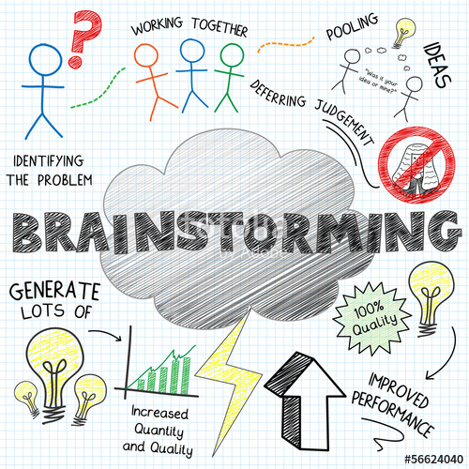

Figure : Brainstorm

We use this method to solve some problems with new ideas, which gathered from group members.

Following are the process, which shows how we sort out some problems using brainstorming method:

1. **Selecting training event topic**

**a.** Preparing the group – To select the training event topic we arranged a group discussion. The group meeting was held on our HND lab. In that meeting, we discussed that what the content of our training program is.

**b.** Present the problem – The main objective of that meeting was about what is the content we are going to do it on our training program. The members suggest so many ideas and topics that are related to IT industry. Our president wrote down those ideas in the whiteboard. Some of the topics that are suggested include Adobe Photoshop, Windows movie maker, MS Office and Hardware and PC assemble.

**c.** Guide the discussion – After getting ideas from our group members we filter the topics as per their importance and usage on every individual's daily life. Therefore we were finally select MS Office as our topic in the training event.

1. **Selecting target audience**

**a.** Preparing the group – To select the target audience we arranged a group discussion. The group discussion was held on our main hall.

**b.** Present the problem – In that meeting, we discussed that who are the target audience of our training program is. Many types of target audience were suggested by the group members. We list down the target audience one by one on a paper.

**c.** Guide the discussion – At last we discussed the possibilities and facility in approaching the target audience that lists down on the paper. According to the conditions that mentioned above we were select the AL students as our target audience.

1. **Income and expenditure**

**a.** Preparing the group – We arranged a meeting to discuss and plan the income and expenditure. The meeting was held on our class room.

**b.** Present the problem – In that meeting, we wrote down all the expenditure, that will affect our training program. All the ideas and ways of expenditure were gathering from the group members. Also we gathered ideas to getting money to manage the expenditure.

**c.** Guide the discussion – At the end of the meeting, we decided to get money from our management and our group members. Furthermore, we created an effective budget plan.

### **SWOT analysis**

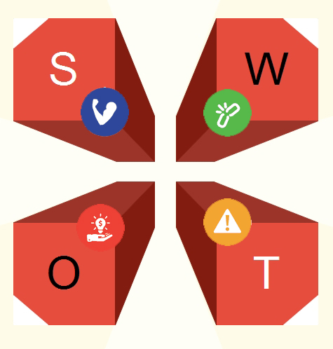SWOT Analysis is a useful technique for understanding our Strengths and Weaknesses, and for identifying both the Opportunities open to us and the Threats we face.

Figure : SWOT

**a. Strength**

Table : Strength

|  |  |
| --- | --- |
| **Self-confidence** | Most of the team members have a high level self-confidence. This is the first time to all of us doing a big project. Although, the members do not get any nervousness or fears of doing a big project. They were always ready to face the challenge and they did that successfully |
| **Team unity** | We have a good unity between us. That was helped us to do the training event very well. The team members helped each other in any circumstances |
| **Very good guidance** | We got very good guidance from our lectures They guided us to face the problems and challenges. |

**b. Weakness**

Table : Weakness

|  |  |
| --- | --- |
| **Misunderstanding problems** | Sometime misunderstanding happened between us. That was leaded us to waste the time and energy. |
| **Poor time management** | Some of the group members do not keep the time management. They were lazy in many times. We wanted to spend some time to motivate them |
| **Poor communications** | There is not good communication between us. That will affect the time and quality of the training event. But we have to move on it. So we had to improve ourselves. |

**c. Opportunities**

Table : Oppertunities

|  |  |
| --- | --- |
| **Learning new things** | We get a good opportunity to learning new things and improve our skills from the training event. Every tasks that we did in our training program, which was helped us to improve ourselves. |
| **We got a good school and target audience** | We got a good school and target audience. The school management was helped us in many situations such as arranging the multimedia and lecture hall. The target audience also cooperated with us. |
| **Very supportive lectures** | Our lectures very supportive on the training program. They helped us and sometime lead the training program when we stuck on it. |

**d. Threats**

Table : Threats

|  |  |
| --- | --- |
| **Delays in getting permission in school** | We faced some delays in getting permission in the school. That was leaded us to deadline pressure and loss of confidence. |
| **Income and expenditure** | We faced some difficulties in getting money, which was we already planned in the budget. |
| **Deadline of the project** | We forced to finished all the tasks and plans before the deadline. It was a very depressive situation for all of us. |

According to the SWOT analysis we can able to determine our strength, weakness, opportunities, and threats. We can manage our threats with the help of our strength. We were able to use the opportunities effectively with the help of the SWOT analysis.

### **Whys method**

5-why-analysis is a group analysis method designed to get to the root of a problem quickly. The technique involves asking why with regards to a problem, getting an answer, and then continuing to ask why in order to uncover layers of the issue, eventually revealing the root cause of the issue.

This is the situation that we did 5 why analysis to solve a critical problem:

We faced critical issues in doing presentation. That would be affecting the quality of the training event.

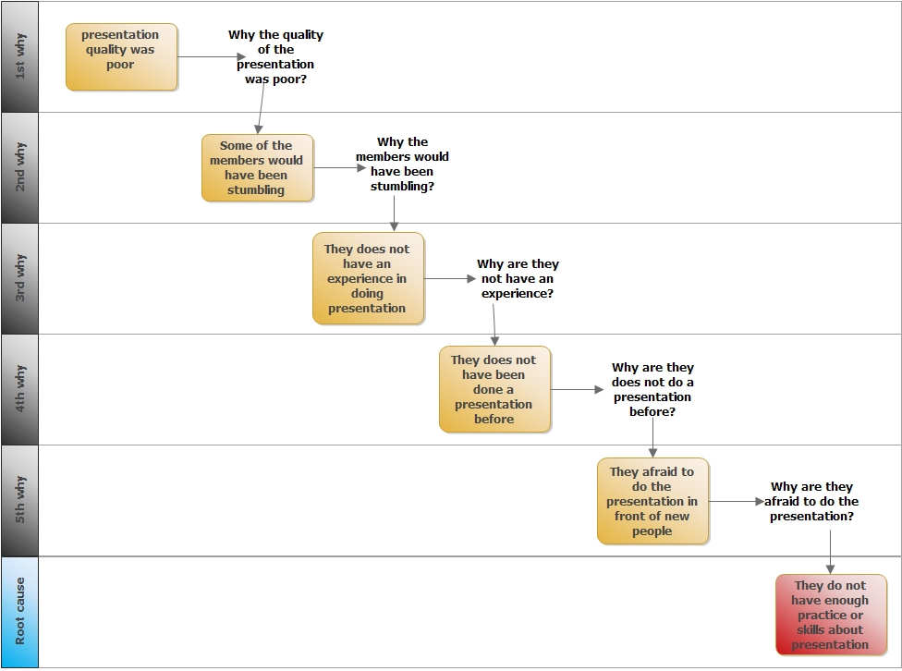

Figure : Whys analysis of our problem

So the root cause of the above problem was identified. Therefore, we want improve the presentation skills of the members. Therefore, we did more presentation practices and rehearsals. The final result of the practice was very impressive. The five why analysis method was helped us to overcome the above problem.

### **Drill down method**

Drill down is a simple technique for breaking difficult problems down into progressively minor parts.

We were used this method to solve our hand-outs and refreshments arranging problems. First we write down our major problem in left hand side and then write down two minor problems that cause the major problem. Then we write down two problems to each minor problem. At last, we write solutions to each problem. We solved the major problem by implementing those solutions.



Figure 6: Drilldown method for our training program

This method was helped us to determine the minor problems that causes major problems.

First we implement the solutions (Right side of the diagram). Every minor problem was solved when we implemented the solutions. Finally, the major problem was solved effectively. We could able to arrange refreshments and hand-outs quickly and we could able to ensure the quality of the foods. Drill down method helped us to overcome from the critical problem.